
TIGER COOKE

Tadhg Cooke Guitars / Vocals

David Redmond Double-Bass, Electric bass

Kevin Brady Drums

Tadhg Cooke put together the trio for the new album, “Fingertips of the Silversmith”, melding the jazz and rock sensibilities of Brady and Redmond, with his own soul and folk influences, to create a new, stripped-down, soulful, dark-folk sound. Influenced by the sparse sounds of The Police, Ben Allison and the arrangements of Ethan Johns, the album was produced by David Geraghty and recorded in Dublin.

Tadhg Cooke released his debut “Wax & Seal” to critical acclaim in 2005, followed by the Japanese version in 2006 on Vivo Discs (The Swell Season, Altan, etc). Deciding to capture the house concert experience, he recorded and released “Live at St Kevin's” in 2007. Cooke has also performed with David Geraghty's band for three years, as a vocalist and guitarist.
Kevin Brady has many years experience playing with some of lreland's most prominent trios including Hammond trio Organics and the Phil Ware Trio, not to mention his collaboration with renowned American jazz pianist Bill Carrothers in the Kevin Brady Trio.
David Redmond is one of the most sought-after bassists in Ireland, having performed with visiting artists such as Bob Dorough, Keith Copeland, Dave Leibman, Jason Rigby, Bobby Wellins, Guy Barker, Ian Shaw, Jacqui Dankworth, Scott Hamilton, and Jim Mullen. He has performed at numerous festivals and clubs throughout the World such as Ronnie Scott's and Pizza Express (London).

Tiger Cooke will be touring in the Autumn to promote the launch of the new album, “Fingertips of the Silversmith”. Cooke's second album will be his first collaboration with Kevin Brady & David Redmond, but the second to be produced by David Geraghty. Geraghty also produced the lo-fi, underground and intensely indie “The Sparks EP” in 2002. “Fingertips of the Silversmith” sees a return to the independent ideal. The album also boasts the formidable talents of Q, aka Colm Quearney, (Lir, Mundy, Jerry Fish), Cora Venus Lunny (Fovea Hex, Yurodny), Sean Carpio (Triple Piglet, Red Rocket) and Justin Carroll (Organics). Not even the most cynical of observers could deny the irresistible attraction of such a line-up, as Cooke draws on some of the finest blues, classical and jazz players in the country. “I’m excited and very lucky to be able to gather them together.”, he enthuses. “There’s a real magic and energy in their playing, which has helped me capture perfectly the dark folk-pop direction that I’m looking for.”

A member of the Living Room Project, Cooke believes that the “collaboration between artists is more important than ever before…. and the fact that everyone thoroughly enjoys the collaboration helps enormously too!”

“Fingertips of the Silversmith” will be released in September 2010.

TADHG COOKE – VOCALS/GUITARS
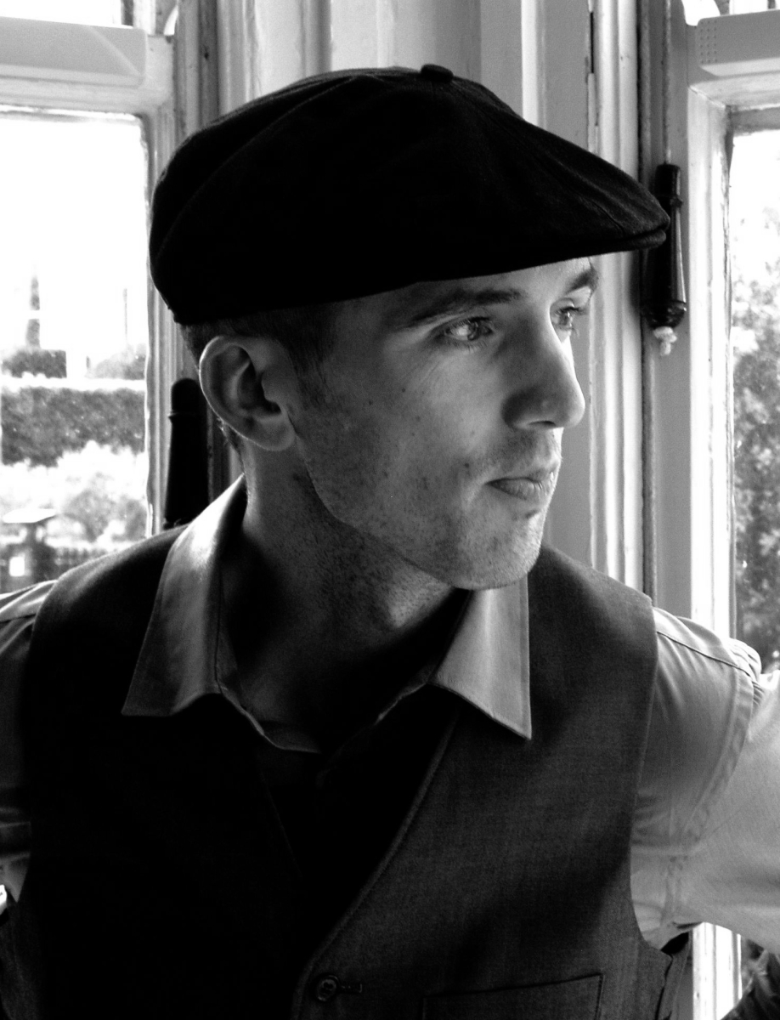
Dublin based songwriter Tadhg Cooke has been writing and performing professionally since 2003. His first nationwide tour saw him performing as a solo act opening for Bell X1. He recorded his debut solo album “Wax & Seal” in Freiburg, Germany. The album was self-released in Ireland in 2005, and released in Japan in 2006 by VIVO Discs (The Swell Season, Altan, etc). A live album followed this with a release of “Live At St. Kevin's”, which was recorded at a house concert in Dublin (featuring David Geraghty, Clare Finglass and Lorcan Cosgrave), in order to capture the typically intimate performances of that time. A concert was organised in London to be filmed with broadcast quality video and sound recording equipment, for use as a promotional tool in Japan. The resulting film was also used on YouTube to help promote the music.
Tadhg has developed, designed and maintained his own website since he began performing, and uses mailing lists to build on each foray into new territory.

He has performed solo throughout his career building up a small but loyal following in Germany, France, London, Northern Ireland and America. Having met David Redmond and Kevin Brady through his work with the David Geraghty project, they have recorded an album that draws on the jazz and rock influences of Brady and Redmond and melds them with the folk and soul elements of Cooke's writing.

- Performs as a vocalist/guitarist with Choice & Meteor Award Nominee David Geraghty. As a group they have performed numerous national tours, and radio/tv promotional tours with highlights including The Choice Music Prize in Vicar Street, and the Electric Picnic.
- Featured as a vocalist on Bell X1's Irish number one single “Flame” and their album Flock.
- Has featured on both of David Geraghty's albums, “Kill Your Darlings” and “The Victory Dance”.
- Has appeared on CEOL '08 for Seachtain na Gaeilge (Irish Language Week) and Song Rise 3 (released in Germany, Switzerland and Austria).
- Member of the Living Room Music Collective.
- Has performed live many times on BBC, RTE, TG4, and television in Munich, both in a solo capacity and with other groups.

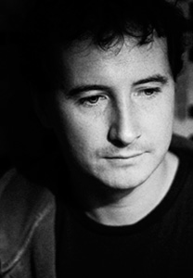
KEVIN BRADY – DRUMS

Dublin based drummer Kevin Brady has been performing professionally for 15 years. He is a founder member of the Hammond organ group Organics and is also a member of the critically acclaimed piano trio led by UK pianist Phil Ware.

After studying classical piano and trumpet from an early age. His interest in drums began at 19 first at Newpark Music Centre. He later attended the Drummer's Collective in New York, where his teachers were Kim Plainfield and Bobby Sanabrias.
Previous teachers have included Jeff Ballard, Matt Wilson, Ben Perowsky, Ralph Peterson, Joe Cusatis, Casey Scheurell, Elliot Zigmund and Keith Copeland.
He achieved a Diploma in jazz performance from the Guildhall School Hall of Music in London and received a scholarship to Berklee College of Music in Boston, USA. In recent times he has performed with international jazz musicians : Ronnie Cuber (baritone saxophone) Ian Shaw (vocalist/pianist), Tim Ries (saxophone), Jesse Davis (saxophone) Guy Barker (trumpet) Jim Mullen (guitar), Bobby Watson (alto), Ulf Wakenius (guitar) Giovanni Mirabassi (piano) Tim Whitehead (sax) and on the home front has worked with Van Morrison, and leading jazz guitarist Louis Stewart and Choice Award nominee singer Dave Geraghty (BellX1).
In 2004 he performed at the Sydney Opera House, Australia, with award winning contemporary Irish group, Grada. He has performed at many jazz clubs & festivals worldwide, Ronnie Scotts, Pizza Express - London, the Jazz Utsav Festival in India, The Euro Jazz Festival, Mexico and numerous other European jazz clubs. In 2008, he was invited to represent Ireland in the European Jazz Colours, Jazz Orchestra in Italy.
He was recently endorsed by Bosphorus Cymbals, USA.

DAVID REDMOND – DOUBLE-BASS
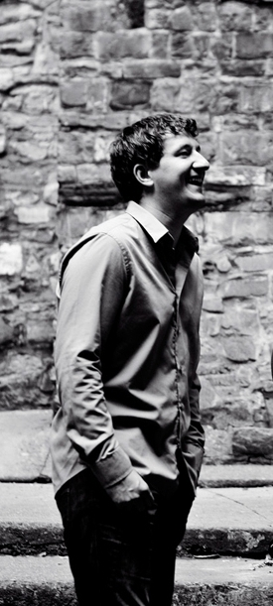

David began playing electric bass at the age of 16 and played in a rock band, he continued to study music throughout his early years. He attended The Newpark Music Centre, Dublin for three years (1999-2002) where he began studying double bass and received the Associate in Jazz Double Bass Performance, awarded by the London Guildhall School of Music and Drama.
In the summer of 2003 he continued his studies and travelled to New York to The School for Improvisational Music and studied under Steve Coleman, Ravi Coltrane, Vijay Iyer, Don Byron and other leading jazz musicians. In 2005, he studied with bassist Drew Gress and in 2007 with Ben Allison. Redmond has performed with visiting artists such as Bob Dorough, Keith Copeland, Dave Leibman, Jason Rigby, Bobby Wellins, Guy Barker, Ian Shaw, Jacqui Dankworth, Scott Hamilton, and Jim Mullen. He has peformed at numerous festivals and clubs throughout the world such as Ronnie Scotts and Pizza Express (London), Mexico (Tour with Phil Ware trio), N.Y.C, Dubai and Abu Dhabi (Cormac Kenevey Quartet), Switzerland, Hungry, (Yurodny) and Spain.

ALBUM & LIVE REVIEWS

“Charting a course between noir-ish torch-songs and heart-on-sleeve folk-pop, 2005 debut album Wax & Seal pointed to the arrival of a fully realised talent.”
Standing apart from the singer-songwriter mainstream can be quite a chore nowadays. Tadhg Cooke, a Meath-born strummer with a line in Jeff Buckley-tinged folk rock, makes a greater effort than most. For one thing, he is seldom without his trademark fedora hat. Donning 1920s-style headgear may not seem a hugely rebellious gesture, yet you wouldn’t catch Damien Rice or Glen Hansard at it. Which is probably the point. There’s lots of theatricality in Cooke’s music too. Charting a course between noir-ish torch-songs and heart-on-sleeve folk-pop, 2005 debut album Wax & Seal pointed to the arrival of a fully realised talent. Since then, Cooke has bravely followed his own route, favouring smaller theatre venues over sweaty rock clubs and touring extensively abroad. Whether this independent streak will be enough to win a substantial fanbase remains to be seen. Certainly, there are some promising harbingers : the 2006 single Know You Hate Me was a minor radio hit; support slots with Damien Dempsey and Bell X1 have further raised his profile. And at last year’s Electric Picnic he shared a stage with the latter’s guitarist, Dave Geraghty, and violinist Cora Venus Lunny. For now Cooke remains largely an anomaly : an Irish singer who looks and sounds like nobody but himself.
Gig Review – Eamon de Paor, Metro

“Eminently likeable, utterly enviable.”
Comparisons can be odious, but think Badly Drawn Boy crossed with Gallagher & Lyle, with a tincture of John Lennon tossed in for good measure, and permit yourself the wryest of smiles. Tadhg Cooke’s solo debut crisscrosses so many terrains that your musical compass may quiver with the sheer magnetic challenge of Wax & Seal. It’s the sleight of hand in his wordplay that charms. A computational linguist, Cooke gets his kicks by applying a distinctly poetic sensibility to the music: placing the right words in the right order. George’s St Arcade is the stuff of magical maudlin bedsitland; Sparks is drawn from the same word well as Arthur Riordan’s Improbable Frequency. Eminently likeable, utterly enviable. ****
“Wax & Seal” review – Siobhán Long, The Irish Times

“Soft yet strong, it’s got that Jeff Buckley quality to it that most vocalists crave.”
So Saturday begins, again at The Olympia, this time with Tadhg Cooke. Cooke’s voice immediately grabs you. Soft yet strong, it’s got that Jeff Buckley quality to it that most vocalists crave. Given a fair wind, he could soon be looking to headline this venue next year.
HWCH Festival Review - Steve Cummins, Hot Press

“Wax & Seal is a confident, impressive debut”
“his highly assured debut album “Wax & Seal” sounds as far removed from the beardy brigade of po-faced strummers as Pablo Aimar’s deft touches are from the journeymen footballers of, say, West Brom. Thankfully, it’s also a refreshingly cliché-free zone.
Take album standout “I Know You Hate Me”, a post break-up song par excellence, where far from lamenting the loss of his one true love, our hero is rubbing her nose in the fact that he’s moved on, with a chorus that most would-be troubadors would trade their broken hearts for: “I got a new love breaking me in / helps me forget about the way I’ve been”.
Unlike many songwriters, Cooke can do happy as well as melancholy: the joyous “Live What You Feel” wangles free from the stranglehold of earnestness to soar into seriously celebratory airspace.
“Wax & Seal” is a confident, impressive debut that’s best summed up by Cooke himself, on the gorgeous “Like A Stone”: “I don’t believe your stories / I can’t believe your truths / But you’re sweetly infectious / And it’s hard to stay aloof”.
“Wax & Seal” album review – John Walshe, HotPress

“Unique brand of shimmering rock”
“Cooke’s unique brand of shimmering rock”
“Cooke does a neat line in understated emotive acoustic rock, and this EP is gilded with intimacy and introspection”
“success and acclaim is very much his for the taking. ”
“George’s St Arcade” single review – Tanya Sweeney, HotPress

“One of the finest singer/songwriters in this country”
‘One of the finest singer/songwriters in this country to not receive the plaudits that he deserves, Tadhg has something a little special about him. His ability to mould together sensitivity and elegance with his remarkably distinctive voice casts him high above similar artists. His album “Wax & Seal” is a great example of just how good he is.’
Gareth Maher, CLUAS.com

“sung with a velvet voice to a virtuoso guitar, indeed a small sensation!”
The big discovery of the evening is the phenomenal songwriter Tadhg Cooke from Ireland… His dreamy songs that float between melancholy and wit are acoustic pop pearls with a breath’s touch of jazz, sung with a velvet voice to a virtuoso guitar, indeed a small sensation!
Gig Review - tz (TagesZeitung), Bayern, Germany

“Instead of being yet another dreary exercise in introspection, Wax & Seal is a vibrant album with a poetic sensibility and a keen eye for life’s absurdities.”
The problem with Irish singer-songwriters today is that many of them seem to have a vocabulary of about fifty words (four of them being ‘my’, ‘girlfriend’s’, ‘left’ and ‘me’). Tadhg Cooke is thankfully a little different. The young Meathman’s soft dreamy compositions are driven by lyrics that are consistently arresting and thought-provoking. And instead of being yet another dreary exercise in introspection, Wax & Seal is a vibrant album with a poetic sensibility and a keen eye for life’s absurdities. There’s more than enough fine songs on this impressive debut to suggest that he’s got a big future ahead of him. ****
Album review – Andrew Lynch, Entertainment.ie

You can become engrossed in Tadhg Cooke’s songs or simply listen to the low key, but refreshingly individual voice.
Badische Zeitung, Baden Würtenberg, Germany – Lukas Meyer Blankenburg

TIGER COOKE
PHONE: +353 (0) 87 7989 686
eMAIL: info@tigercooke.com
www.tigercooke.com
www.livingroomproject.com
www.myspace.com/tadhgcooke

